Jan Rehwaldt

University of Tartu, Social Informatics, March 2012

*Exercise 4: Find an academic research paper on Human Computer Interaction and read through - prepare a 1-2 page summary of that article.*

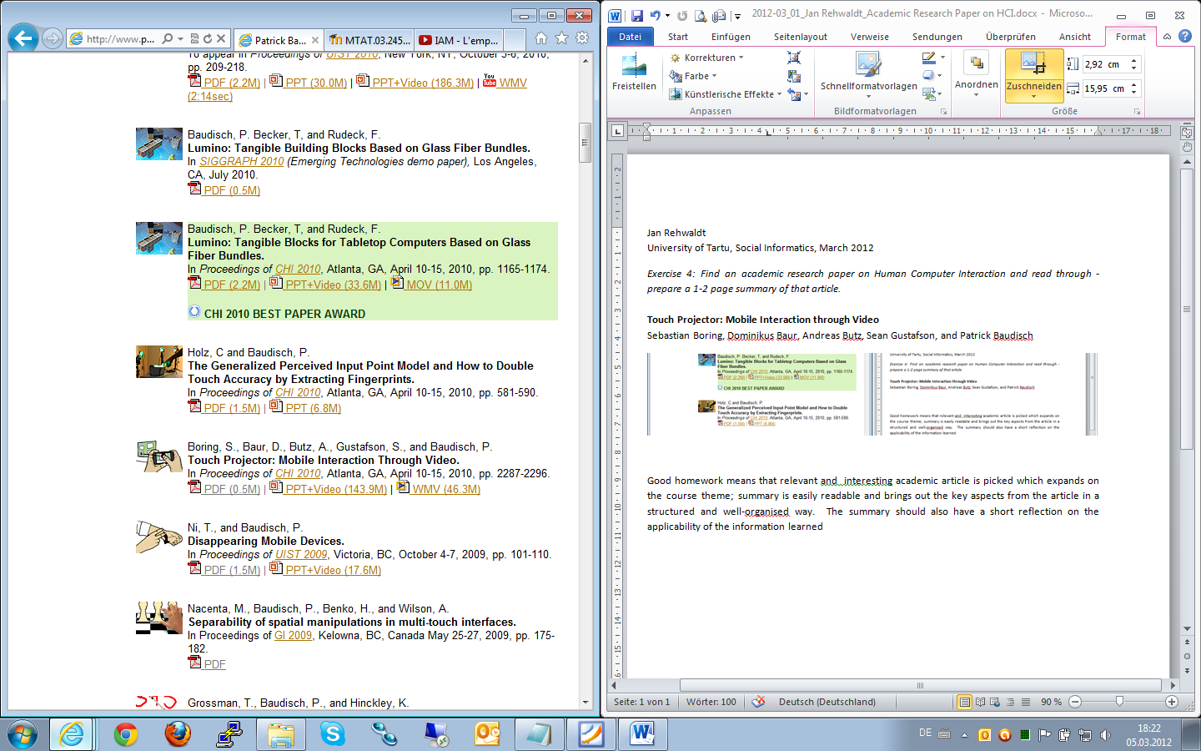

http://www.patrickbaudisch.com/publications/index.html

The given article *Touch Projector: Mobile Interaction Through Video* by Sebastian Boring et al. was written in 2010 and proposes the technique *Touch Projector*, which allows to remotely control multi-display environments by touch input on a mobile device showing a live video of the original scene.

The proposed system uses basic cameras located at the back of a mobile device, e.g. a mobile phone, to provide a live video of a distant system’s state, e.g. the wall projector or laptop screen scenery, allowing a touch-alike interaction affordance without requiring the manipulated device to provide support for it or be reachable. Holding the mobile device with the non-dominant hand a user may point the camera to a certain part of a screen and manipulate captured objects with his dominant hand by means of the mobile device’s touch input capabilities. Each input is live projected to the remote machine resulting in immediate state changes.

Through advanced knowledge of spatial devices equipped with controlling software and an established wireless connection is the handheld device able to translate the touch-input coordinates to the distant system’s coordinates and manipulate the target objects the user points at even across display-boundaries. Spatial devices are identified by their display content, which does circumvent the requirement of modelling the environment and supports rearranged display setups.

The authors introduce techniques called zoom, temporarily freezing and virtual preview increasing the performance of this approach dramatically. Digital zooming allows users to enlarge certain regions of the camera image without moving closer to the target display. The user interaction is additionaly supported by automatic zooming triggered when no display (zoom out) or a new display is recognized within camera range (zoom in). Furthermore a technique is provided to freeze the live image for an indefinite amount of time allowing the user to achieve higher precision while pointing on long-distant displays. Freezing is extended with virtual preview, which generates live images on the spatial device and integrates them into the frozen screen combining the advantage of immediate feedback with higher precision interaction.

It is shown that users achieve much better results with those techniques. In multi-display environments the task execution speed (1.5s, before 3s) and failure rate (2.2, before 5.5) is halved when working with rather small display items (0,75cm). No significant speed improvement is recognized for bigger items (3cm).

___

Bye the way, a summary **never** contains a reflection (= opinion), ‘cause it’s a summary[1]. Same problem as with task one, which did not ask for a summary, even though you expected it to be one (as visible in your comment to my first homework). I guess it is helpful if the lecturer and you elaborate same expectations making them generally less wishy-washy.

1. http://web.hc.keio.ac.jp/~hjb/How_to_write_a_summary.html